Wenjun Anna Wu, Ruiyan Maggie Huang, Rui Ann Gu, Leong Blake Wong

Chemistry 1: **MSA project further explanation**

Paul Montbriand

03/28/2019

**Abstract**

Our project is an invention of a spray medical—Speed-Cure Spray—that can be used to treat accidental cuts, both smaller ones and larger ones. When the skin is cut and the medicine is sprayed onto it, through a molecular self-assembly process, it would treat the bleeding part and help it recover.

**Introduction**

As a survey conducted by our groups shows, while purchasing band-aids, people pay a lot attention to waterproofness and healing ability (Figure 1); and none of them are satisfied with the current band-aid they are using (Figure 2). We thus aim to come up with a better idea that can exceed all the product in the current market.

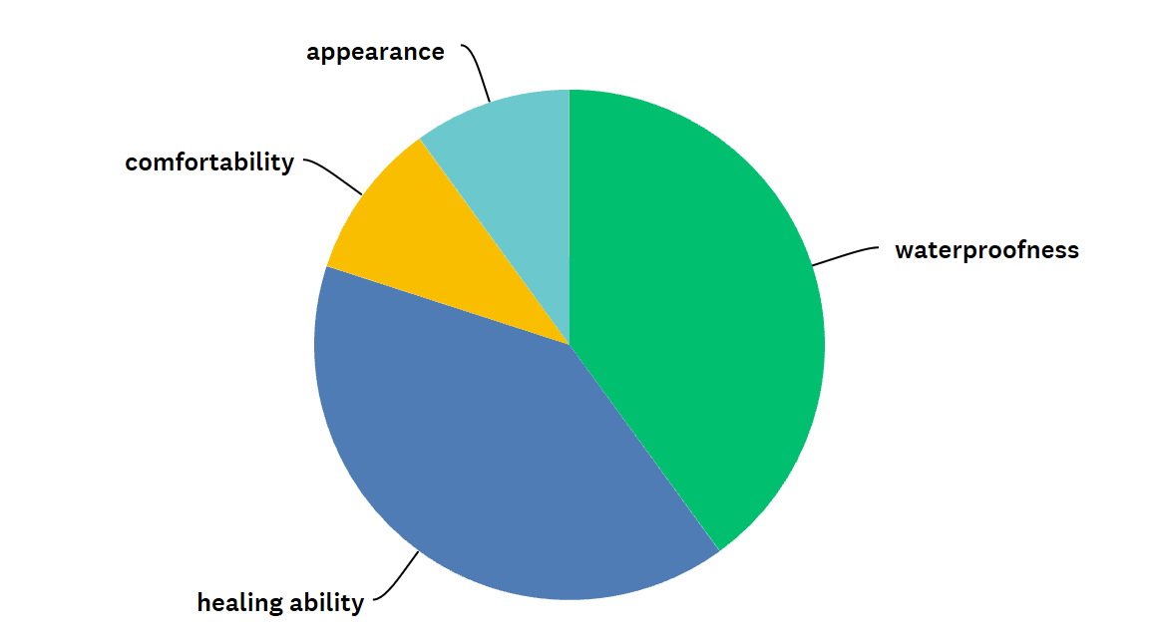

Figure 1. What do you value most while purchasing band-aids?

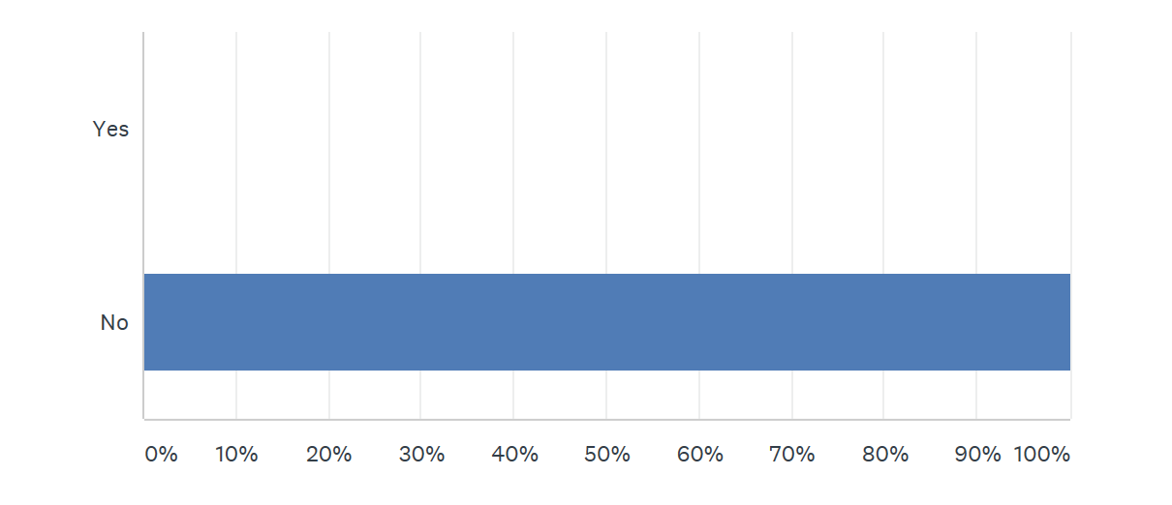

Figure 2. Are you satisfied with the band-aid you are currently using?

**Idea generating**

We followed the process of design idea generating process and formed several original ideas.



The primary one is similar to one in the market, liquid band-aid. The principle of the spray is to apply MSA to form a layer that covers the cut, which is the same principle as all the products in market.

Based on that idea, we further thought about a pray that make molecules to form a net structure. However, the obstacles lie in the difficulty to control molecules in that structure.

Lastly, we came up with this idea of Speed-Cure Spray, the principle of which will be further explained in process part.

**Process**

Some molecules with similar structure as protein and amino acid are contained in the spray (so that they can self-assemble with the protein in human body), and once it approaches the cell wall, it would start to self-assemble, with the charges and the shapes that can be fitted into each other (Figure 3), the molecules in the spray will form spiral structures inside the cut, connecting the 2 sides of the walls of the cut. After the structure is formed, they start to contract due to the attraction between opposite charges and work just like stitches in hospital (figure 4). It can only start to self-assemble and form structure as the surrounding temperature is greater than 30C°, which is close to normal human body temperature.

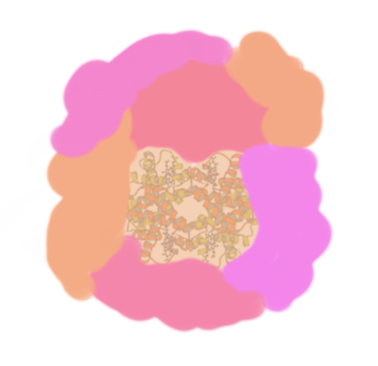Figure 3. the molecules fit into each other

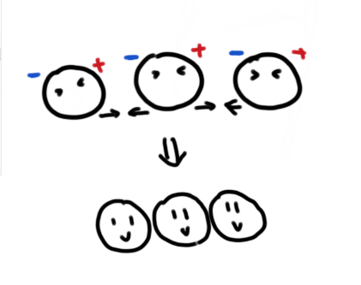

Figure 4. The molecules start to contract.

**Advantage:**

This spray is special because the function of it is far beyond the other similar projects. For example, the liquid band-aids. It can cover the wound and give our body enough time to heal at the same time it can avoid the bacteria getting into the wound. However, what makes the spray better is that it not only can avoid the bacteria, but also enhance the body's self-healing speed. Our project is a useful medical which treats the deep and wide wound that band-aid cannot achieve. Comparing to the other projects in the market, Speed-cure spray is more useful and convenient.

**Limitation**

However, Speed-Cure Spray does have limitations: when the spray is not in use, it should be kept in a freezer; also, the patient does need to sterilize before using the spray. Thus, we are still investigating on further improvement on the current product.

Also, some of the photos in the video is not of the right order: the picture that should be put to explain the contracting process was put a little bit early before the connect one.